Digital image representation

Virtual image, a point or system of points, on one side of a mirror or lens, which, if it existed, would emit the system of rays which actually exists on the other side of the mirror or lens.

Vector images

One way to describe an image using numbers is to declare its contents using position and size of geometric forms and shapes like lines, curves, rectangles and circles; such images are called vector images.

Vector image
draw circle
center 0.5, 0.5
radius 0.4
fill-color yellow
stroke-color black
stroke-width 0.05
draw circle
center 0.35, 0.4
radius 0.05
fill-color black
draw circle
center 0.65, 0.4
radius 0.05
fill-color black
draw line
start 0.3, 0.6
end 0.7, 0.6
stroke-color black
stroke-width 0.1

A vector image is resolution independent, this means that you can enlarge or shrink the image without affecting the output quality. Vector images are the preferred way to represent Fonts, Logos and many illustrations.

Defining shapes
It would have been nice to make a smiling face, instead of the dissatisfied face on the left, by using a bezier curve, or the segment of a circle this could be achieved, this being a text focusing mainly on raster graphics though, that would probably be too complex.



The preceding description of an image can be seen as a “cooking recipe” for how to draw the image, it contains geometrical primitives like lines, curves and cirles describing color as well as relative size, position and shape of elements. When preparing the image for display is has to be translated into a bitmap image, this process is called rasterization.

Bitmap images

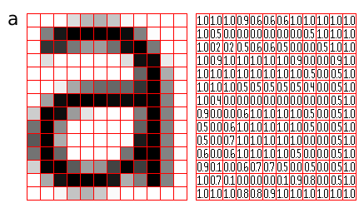
Bitmap-, or raster-, images are “digital photographs”, they are the most common form to represent natural images and other forms of graphics that are rich in detail. Bitmap images is how graphics is stored in the video memory of a computer. The term bitmap refers to how a given pattern of bits in a pixel maps to a specific color.

A rasterized form of the letter 'a' magnified 16 times using pixel doubling

The number of horizontal and vertical samples in the pixel grid is called Raster dimensions, it is specified as width x height.

A bitmap images take the form of an array, where the value of each element, called a pixel picture element, correspond to the color of that portion of the image. Each horizontal line in the image is called a scan line.
The letter 'a' might be represented in a 12x14 matrix as depicted in Figure, the values in the matrix depict the brightness of the pixels (picture elements). Larger values correspond to brighter areas whilst lower values are darker.

Resolution

Resolution is a measurement of sampling density, resolution of bitmap images give a relationship between pixel dimensions and physical dimensions. The most often used measurement is ppi, pixels per inch.

A rasterized form of the letter 'a' magnified 16 times, where each pixel is represented as a circle instead of a square.
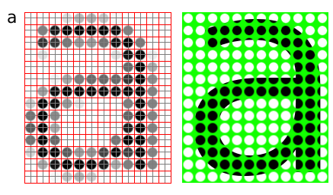

Megapixels

Megapixels refer to the total number of pixels in the captured image, an easier metric is raster dimensions which represent the number of horizontal and vertical samples in the sampling grid. An image with a 4:3 aspect ratio with dimension 2048x1536 pixels, contain a total of 2048x1535=3,145,728 pixels; approximately 3 million, thus it is a 3 megapixel image.

Common/encountered raster dimensions
Dimensions | Megapixels | Name | Comment
640x480 | 0.3 | VGA | VGA
720x576 | 0.4 | CCIR 601 DV PAL | Dimensions used for PAL DV, and PAL DVDs
768x576 | 0.4 | CCIR 601 PAL full | PAL with square sampling grid ratio
800x600 | 0.4 | SVGA
1024x768 | 0.8 | XGA | The currently (2004) most common computer screen dimensions.
1280x960 | 1.2
1600x1200 | 2.1 | UXGA
1920x1080 | 2.1 | 1080i HDTV | interlaced, high resolution digital TV format.
2048x1536 | 3.1 | 2K | Typically used for digital effects in feature films.
3008x1960 | 5.3
3088x2056 | 6.3
4064x2704 | 11.1

Scaling / Resampling

When we need to create an image with different dimensions from what we have we scale the image. A different name for scaling is resampling, when resampling algorithms try to reconstruct the original continous image and create a new sample grid.

Scaling image down

The process of reducing the raster dimensions is called decimation, this can be done by averaging the values of source pixels contributing to each output pixel.

Scaling image up

When we increase the image size we actually want to create sample points between the original sample points in the original raster, this is done by interpolation the values in the sample grid, effectivly guessing the values of the unknown pixels

Sample depth

The values of the pixels need to be stored in the computers memory, this means that in the end the data ultimately need to end up in a binary representation, the spatial continuity of the image is approximated by the spacing of the samples in the sample grid. The values we can represent for each pixel is determined by the sample format chosen.

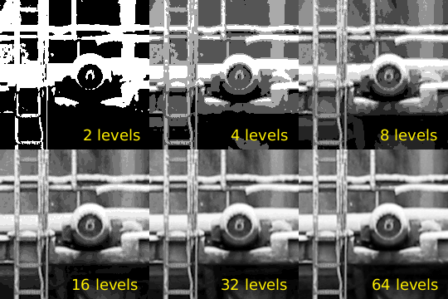

8bit

A common sample format is 8bit integers, 8bit integers can only represent 256 discrete values (2^8 = 256), thus brightness levels are quantized into these levels.

12bit

For high dynamic range images (images with detail both in shadows and highlights) 8bits 256 discrete values does not provide enough precision to store an accurate image. Some digital cameras operate with more than 8bit samples internally, higher end cameras (mostly SLRs) also provide RAW images that often are 12bit (2^12bit = 4096).

16bit

The PNG and TIF image formats supports 16bit samples, many image processing and manipulation programs perform their operations in 16bit when working on 8bit images to avoid quality loss in processing.

Floating point

Some image formats used in research and by the movie industry store floating point values. Both "normal" 32bit floating point values and a special format called half which uses 16bits/sample. Floating point is useful as a working format because quantization and computational errors are kept to a minimum until the final render.
Floating point representations often include HDR, High Dynamic Range. High Dynamic Range images are images that include sampling values that are whiter than white (higher values than 255 for a normal 8bit image). HDR allows representing the light in a scene with a greater degree of precision than LDR, Low Dynamic Range images.

Colors

The most common way to model color in Computer Graphics is the RGB color model, this corresponds to the way both CRT monitors and LCD screens/projectors reproduce color. Each pixel is represented by three values, the amount of red, green and blue. Thus an RGB color image will use three times as much memory as a gray-scle image of the same pixel dimensions.

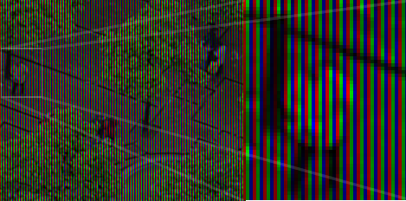

Color image built up of bands of red, green and blue color (This is image illustrates how a laptop display is constructed, note that this image is preferred to be viewed on a computer screen, and not in print.)

One of the most common pixel formats used is 8bit rgb where the red, green and blue values are stored interleaved in memory. This memory layout is often referred to as chunky, storing the components in seperate buffers is called planar, and is not as common.

Palette / Indexed images

It was earlier common to store images in a palletized mode, this works similar to a paint by numbers strategy. We store just the number of the palette entry used for each pixel. And for each palette entry we store the amount of red, green and blue light.
Indexed image
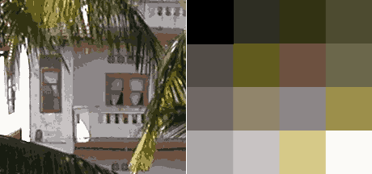

On the left, image using just 16 colors, on the right the palette used for this image. The way an indexed/paletted image works is similar to how paint by numbers work.

File formats and applications

Many applications have their own internal file format, while other formats are more suited for interchange of data. Table ref# lists some common image formats.
Vector File Formats
Extension | Name | Notes
.ai | Adobe Illustrator Document | Native format of Adobe Illustrator (based on .eps)
.eps | Encapsulated Postscript | Industry standard for including vector graphics in print
.ps | PostScript | Vector based printing language, used by many Laser printers, used as electronic paper for scientific purposes.
.pdf | Portable Document Format | Modernized version of ps, adopted by the general public as 'electronic print version'
.svg | Scalable Vector Graphics | XML based W3C standard, incorporating animation, gaining adoption.
.swf | Shockwave Flash | Binary vector format, with animation and sound, supported by most major web browsers.

Raster File Formats

Extension | Name | Notes
.jpg | Joint Photographic Experts Group | Lossy compression format well suited for photographic images
.png | Portable Network Graphics | Lossless compression image, supporting 16bit sample depth, and Alpha channel
.gif | Graphics Interchange Format | 8bit indexed bitmap format, is superceded by PNG on all accounts but animation
.exr | EXR | HDR, High Dynamic Range format, used by movie industry..
.raw, .raw | Raw image file | Direct memory dump from a digital camera, contains the direct imprint from the imaging sensor without processing with whitepoint and gamma corrections. Different cameras use different extensions, many of them derivatives of TIFF, examples are .nef, .raf and .crw
.dgn | Digital Negative | A subset/clarification of TIFF, created by Adobe to provide a standard for storing RAW files, as well as exchanging RAW image data between applications.
.tiff, .tif | Tagged Image File Format
.psd | Photoshop Document | Native format of Adobe Photoshop, allows layers and other structural elements
.xcf | Gimp Project File | GIMP's native image format.

